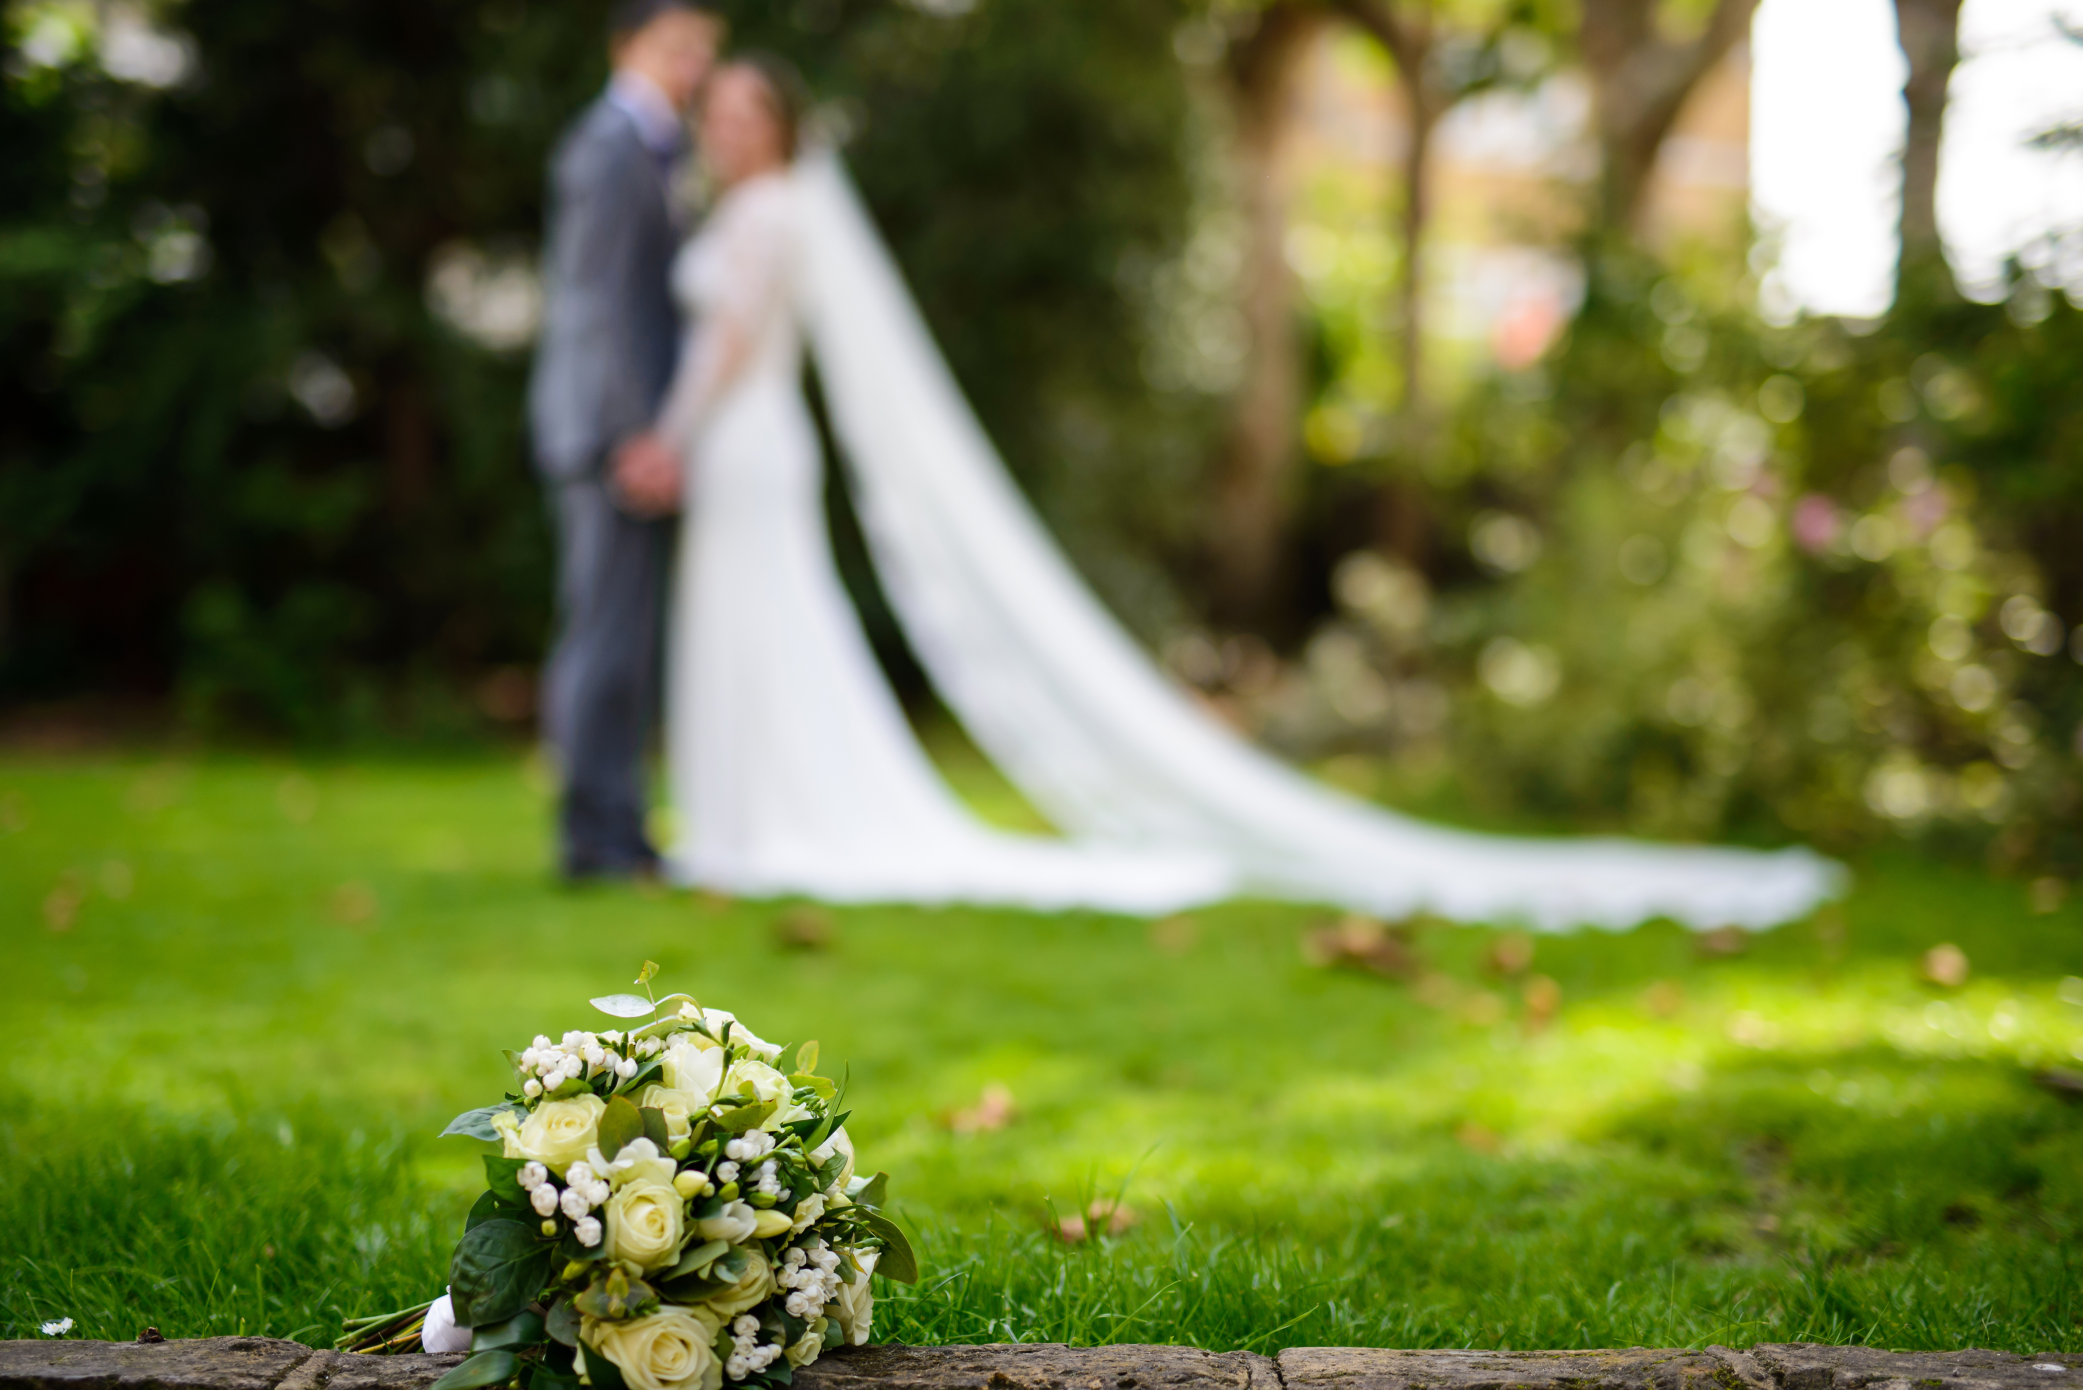
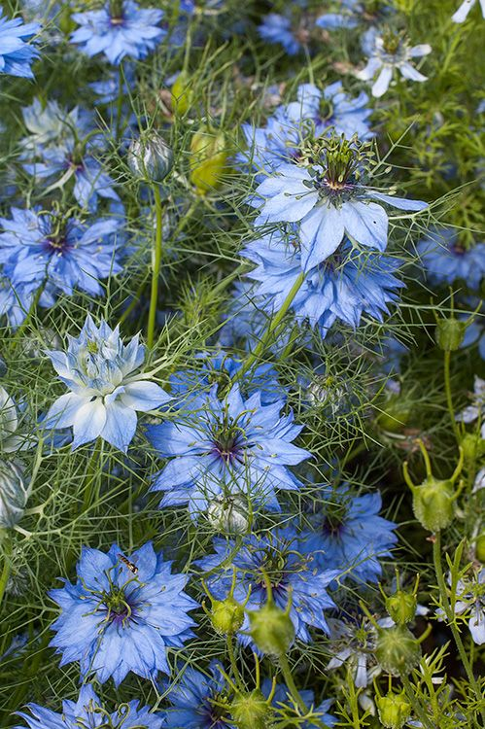
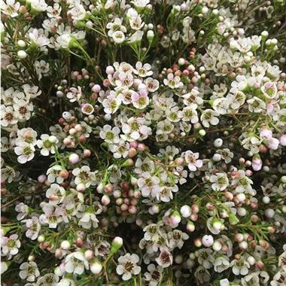
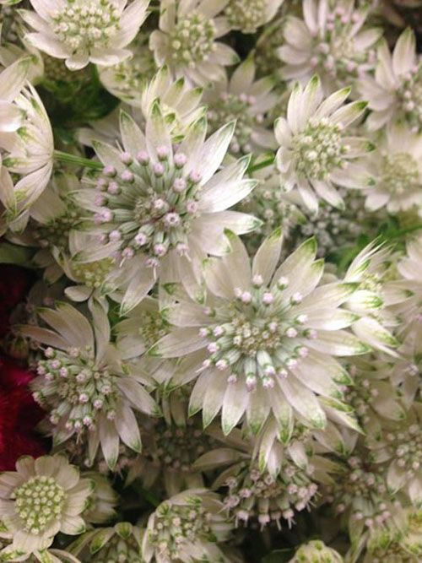
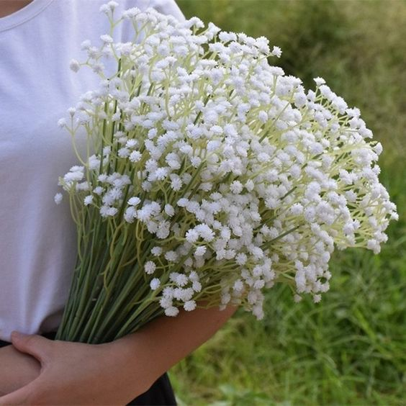
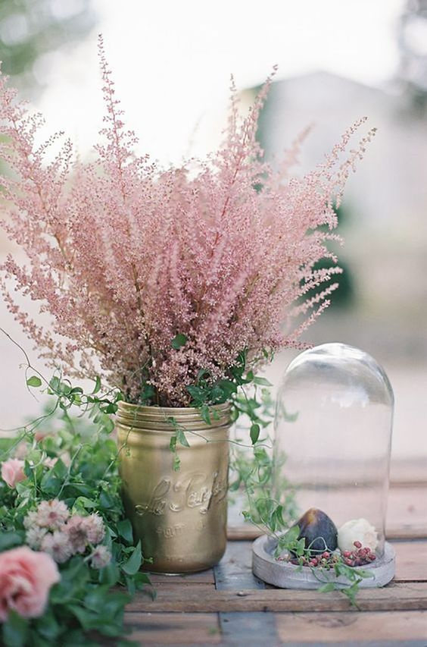
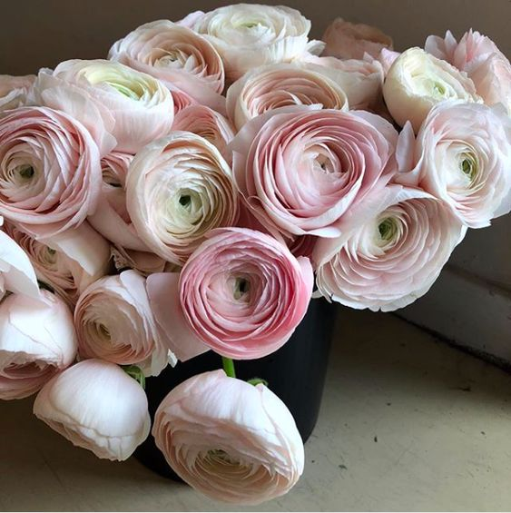
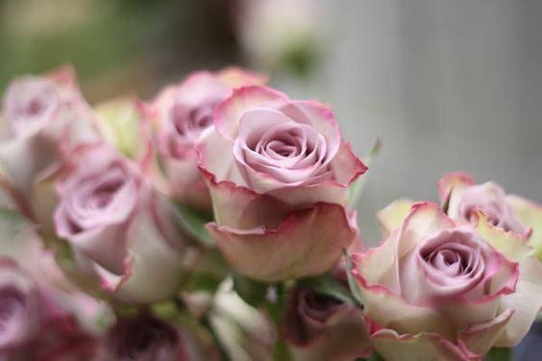
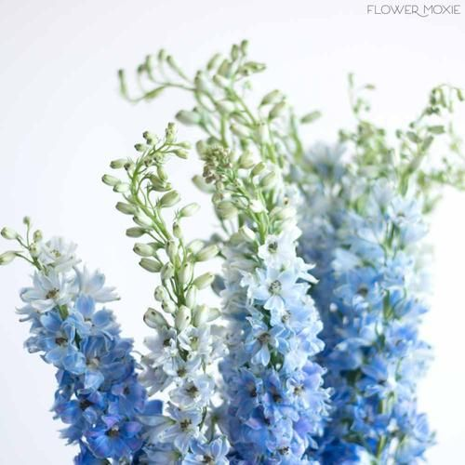
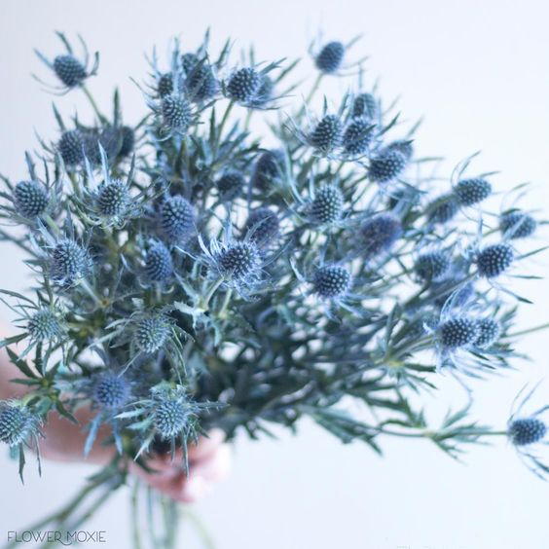
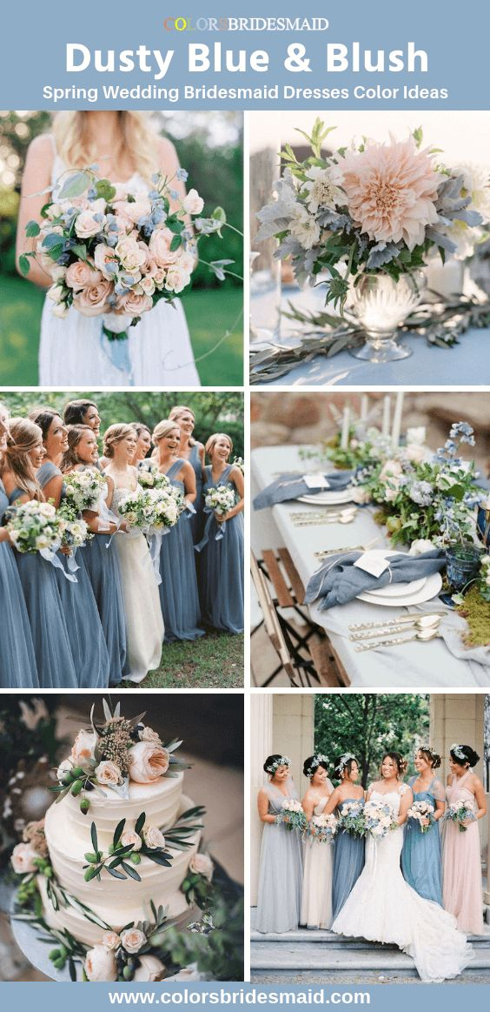
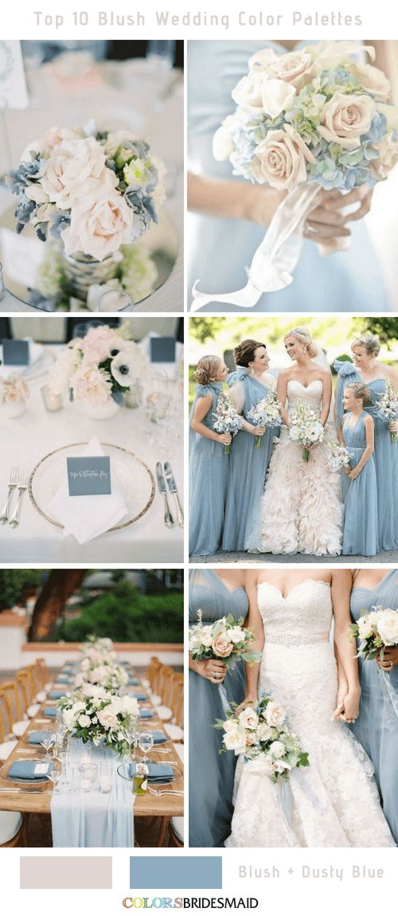
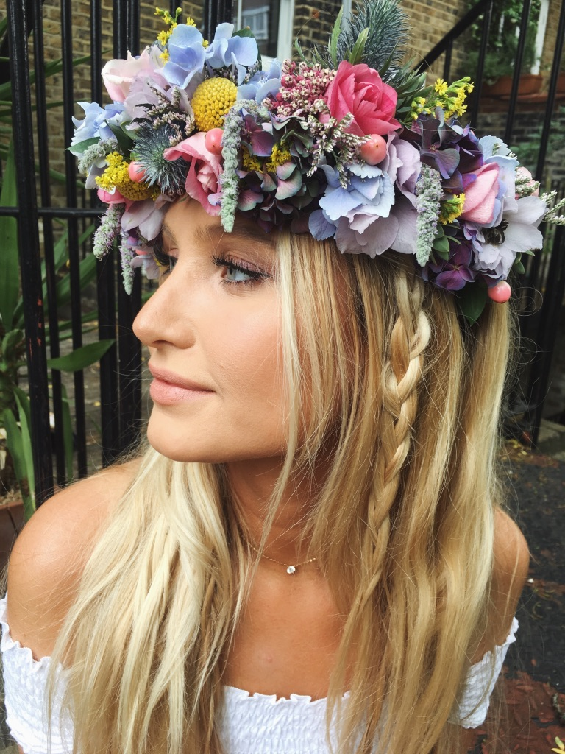
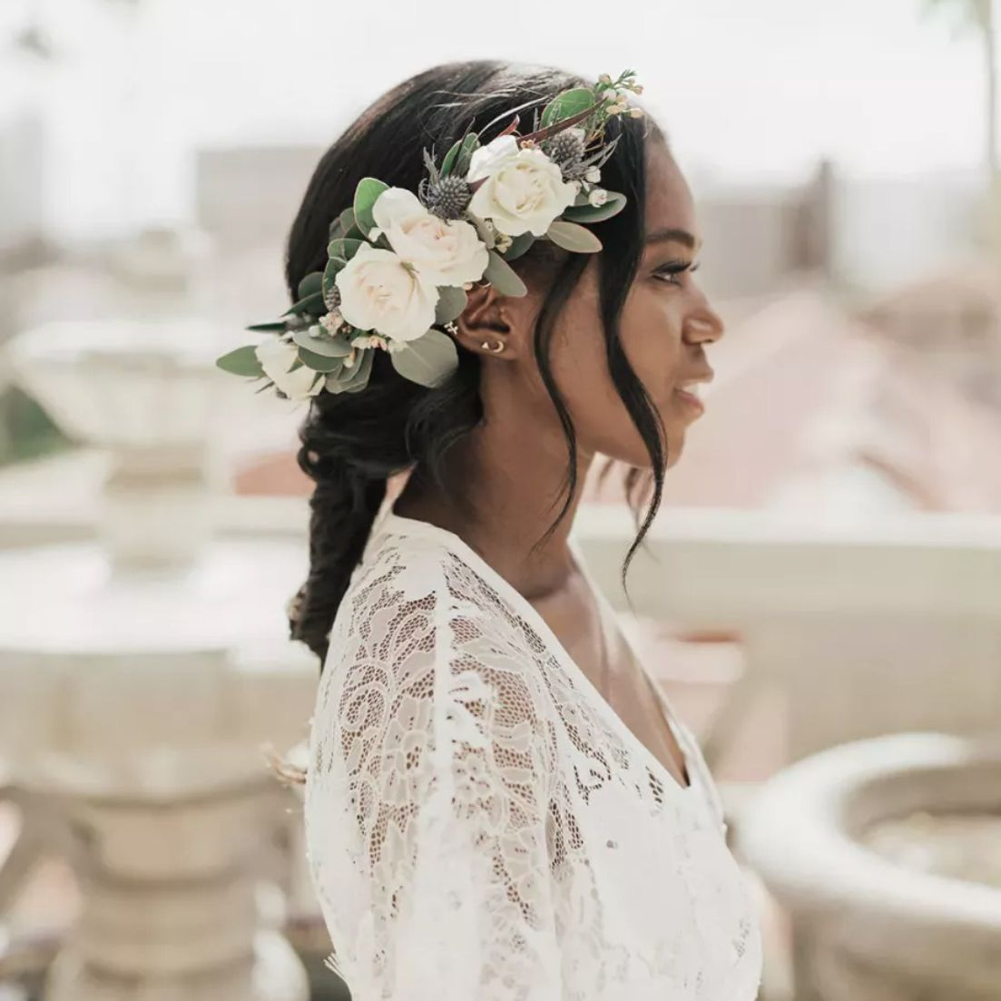
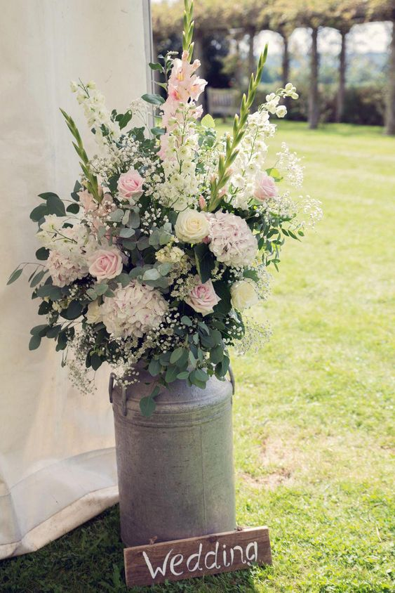
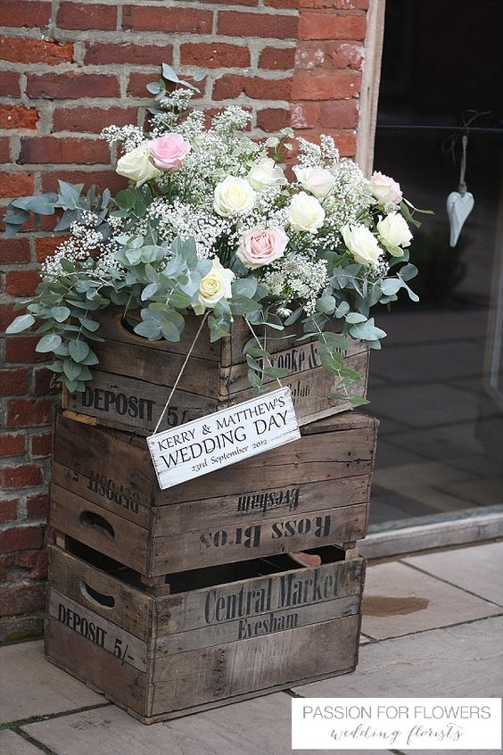
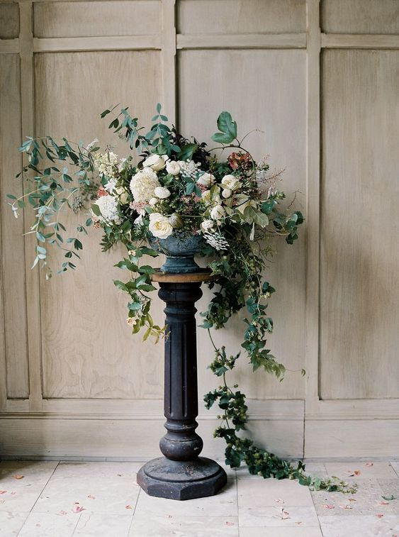
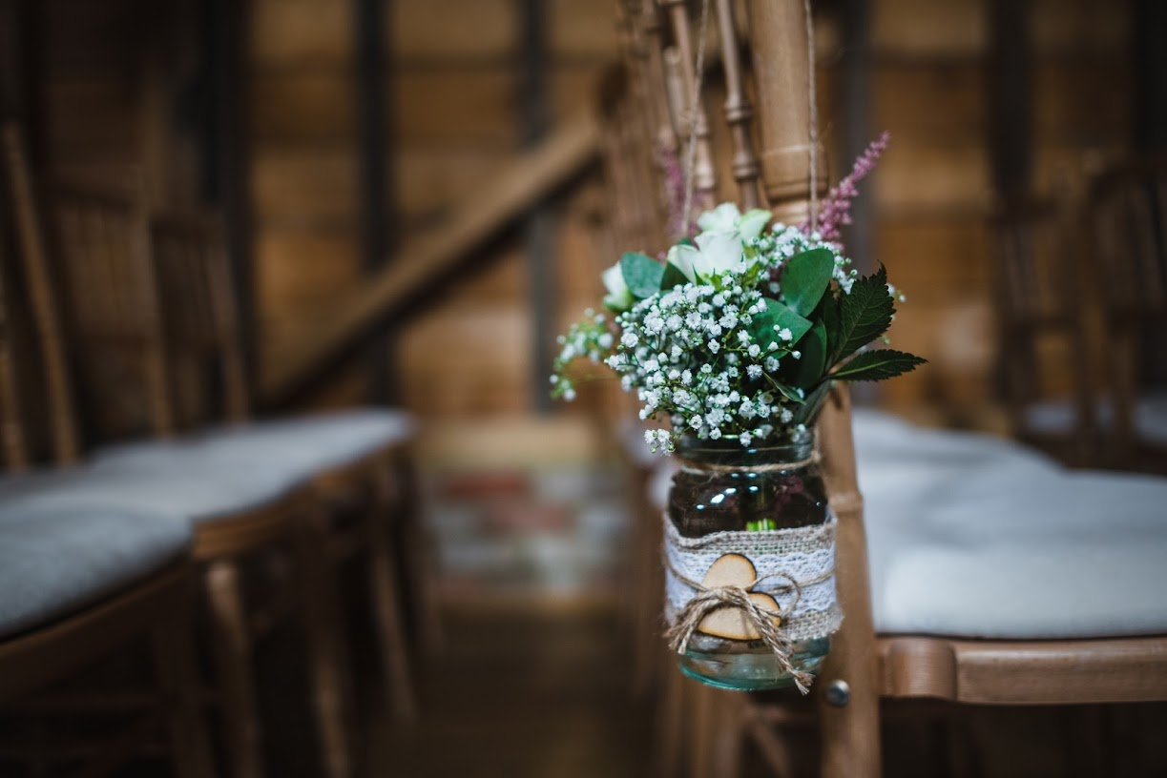
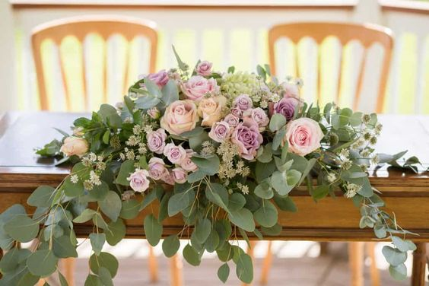
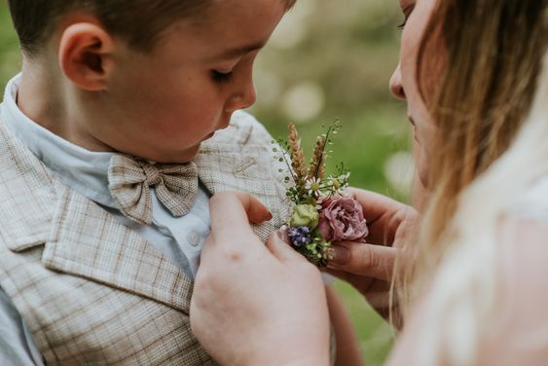
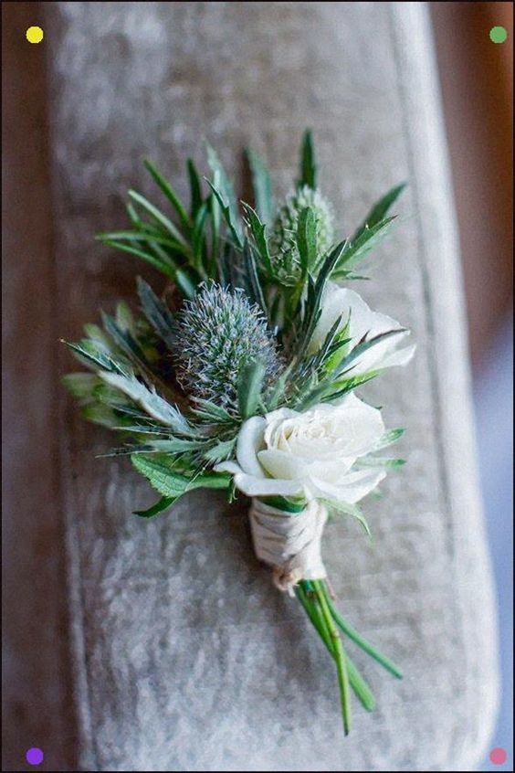
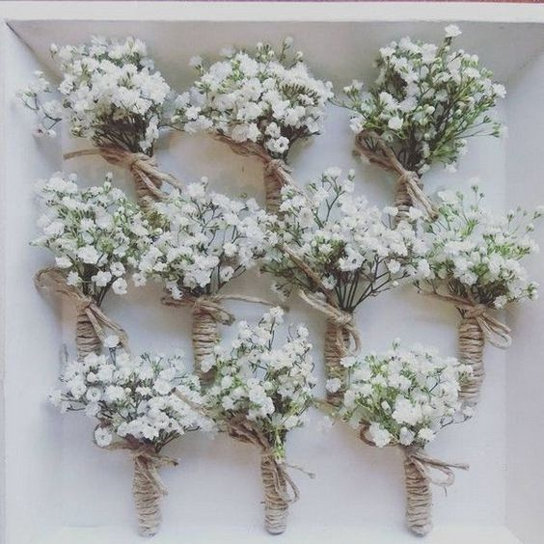
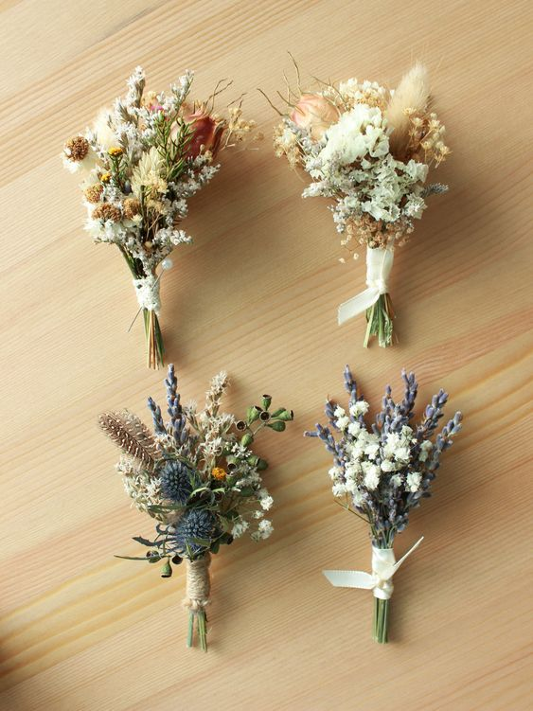
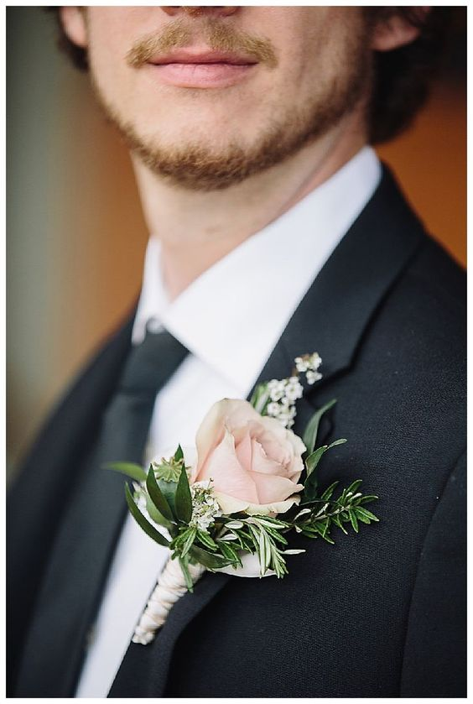
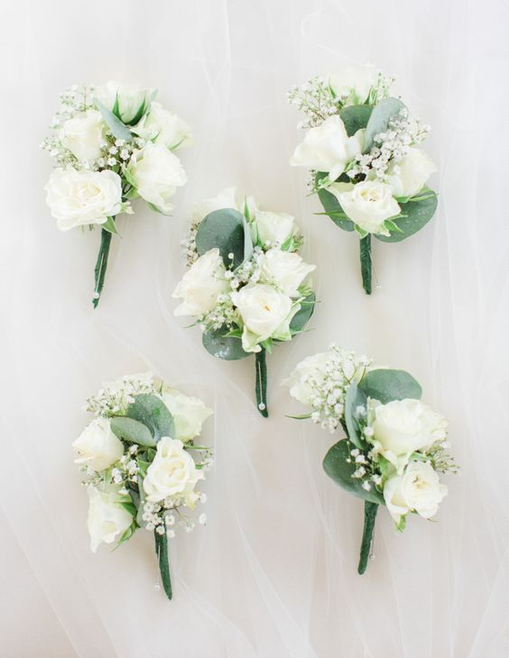
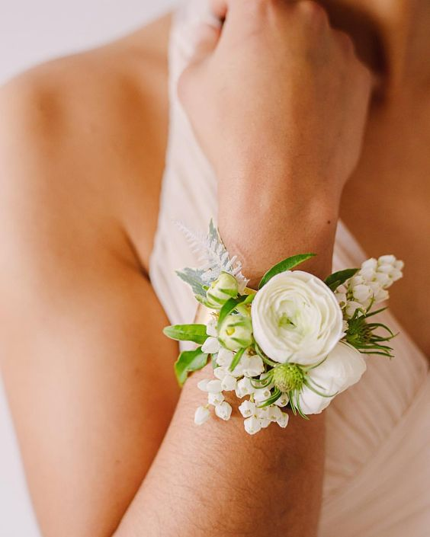
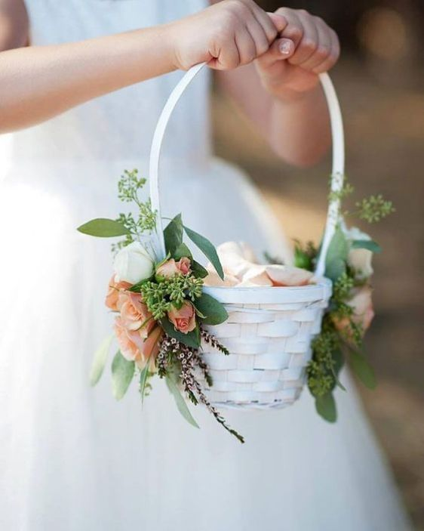
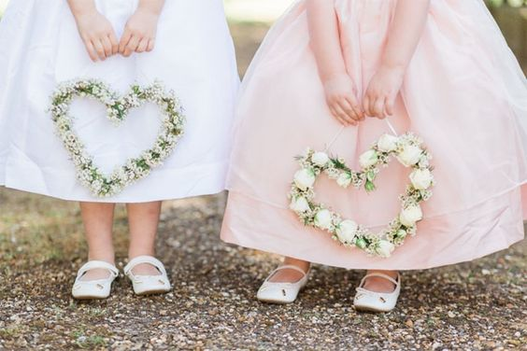
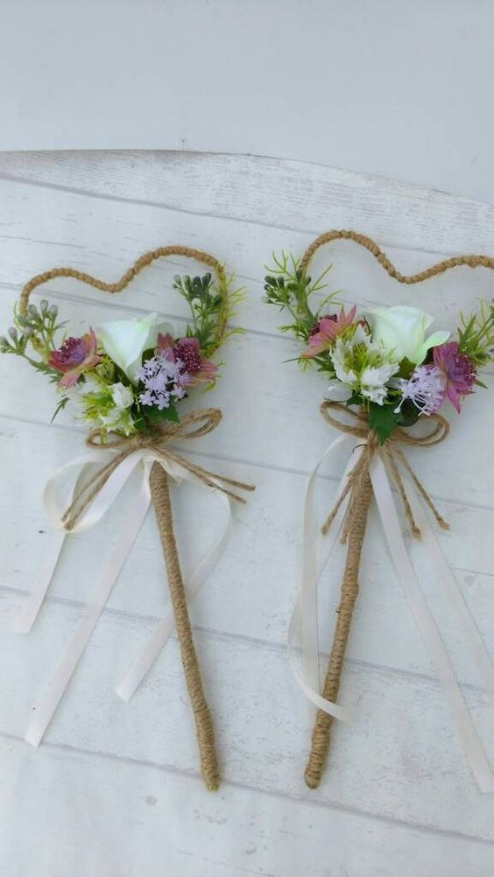
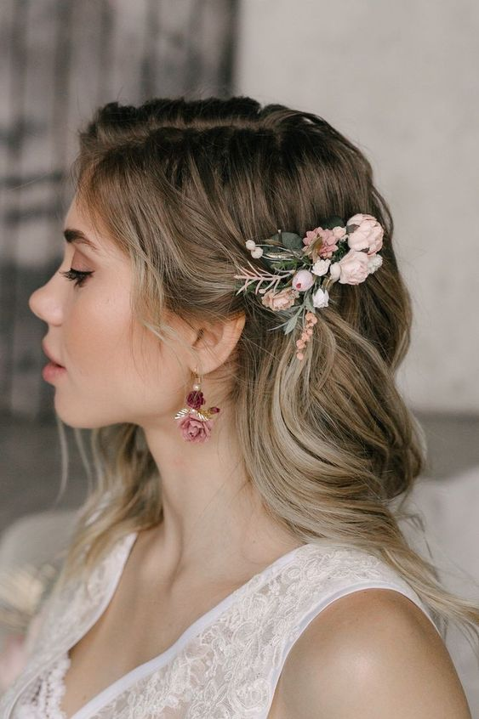
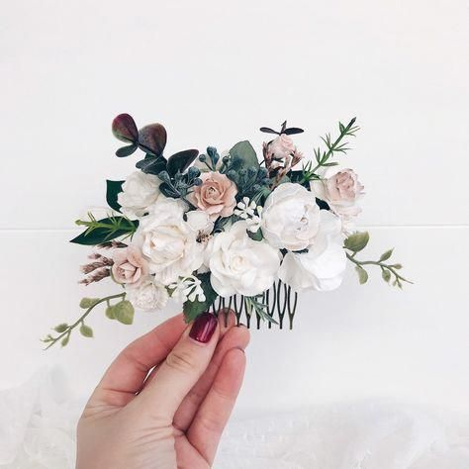
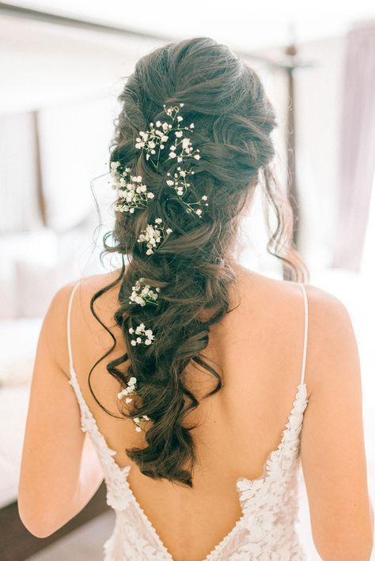
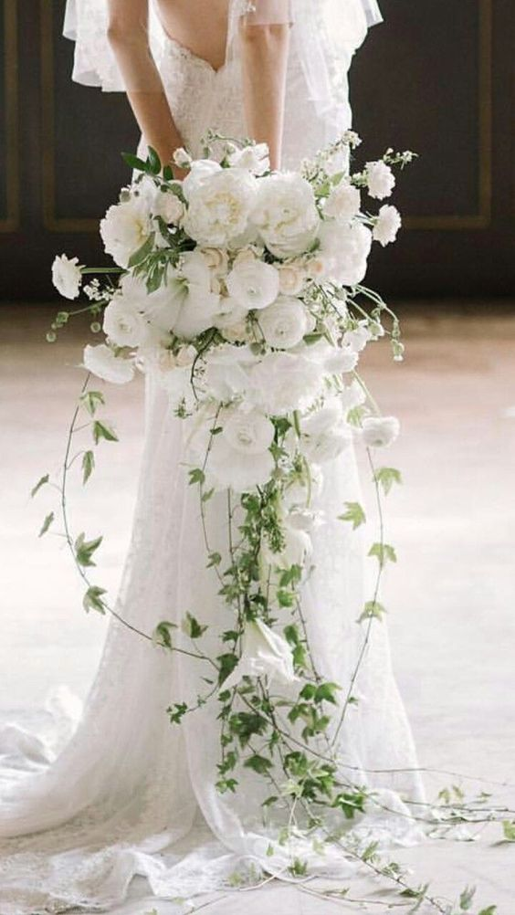
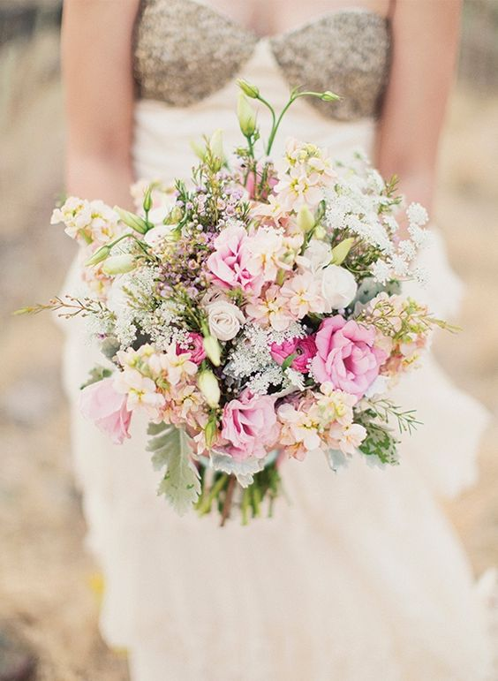
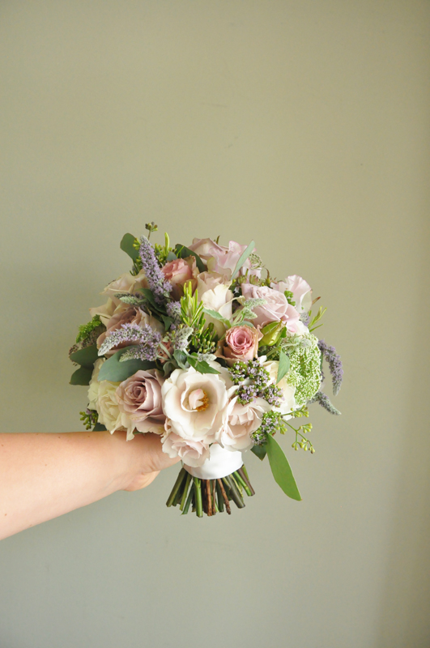
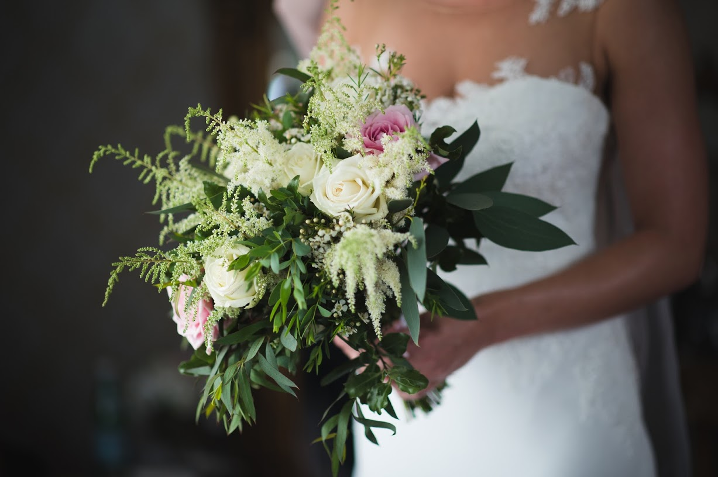
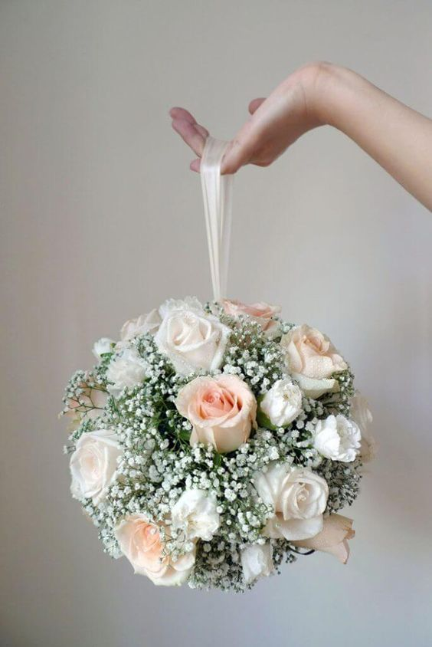
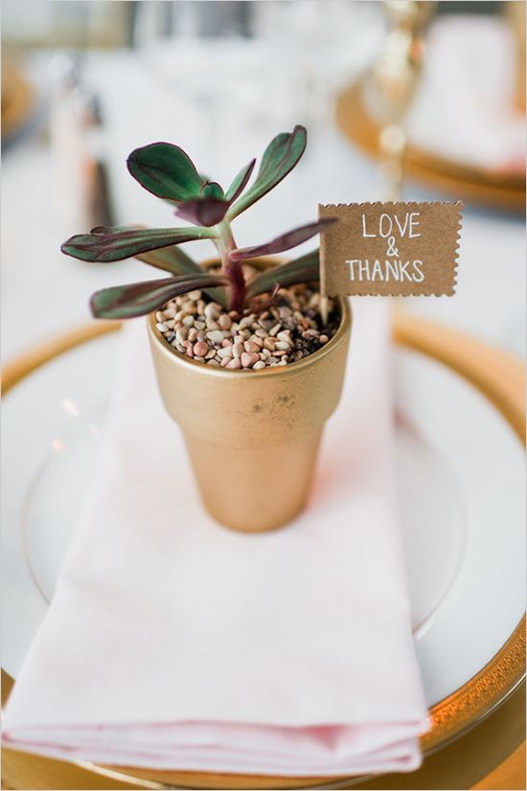
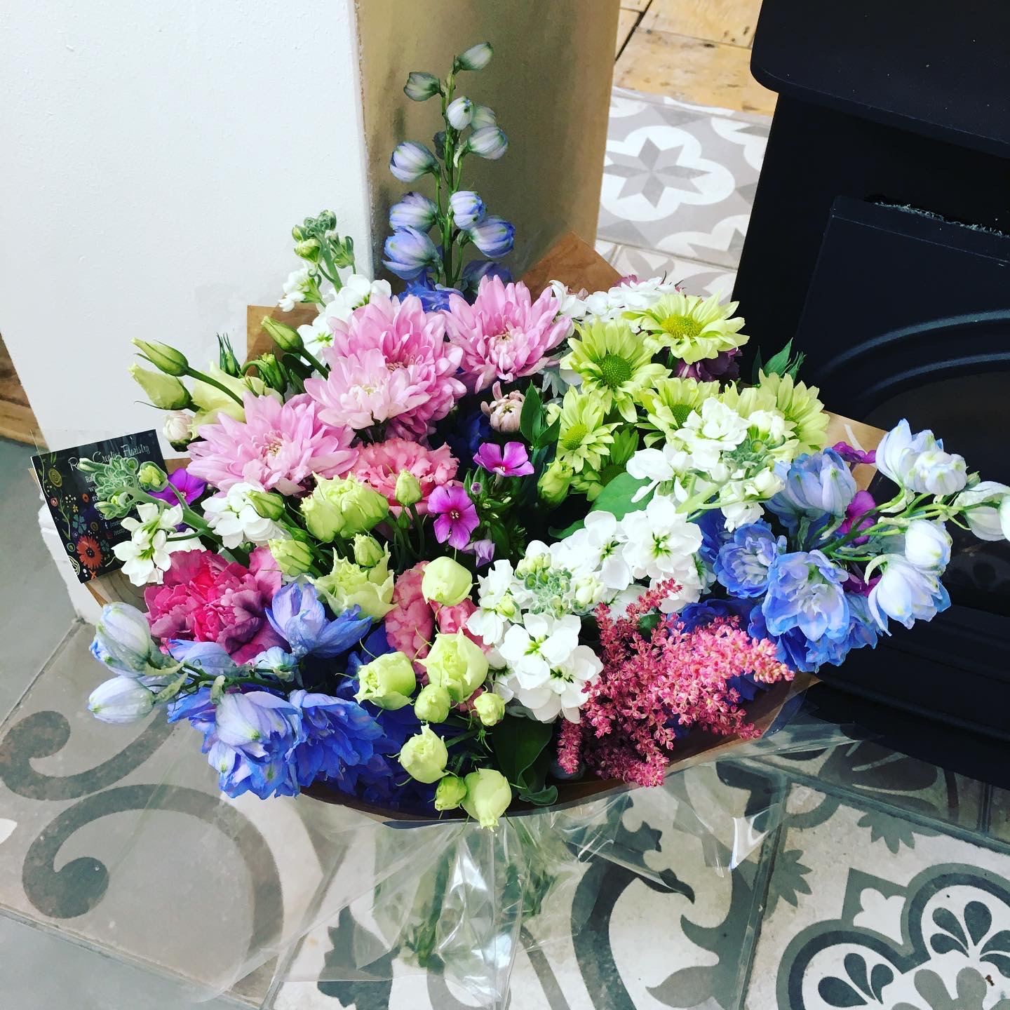
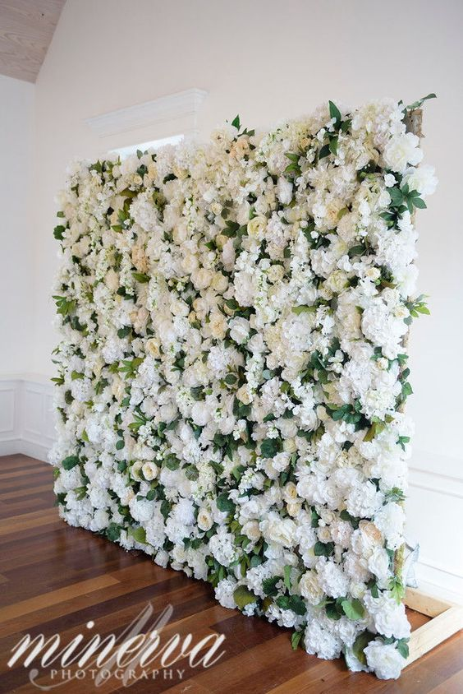
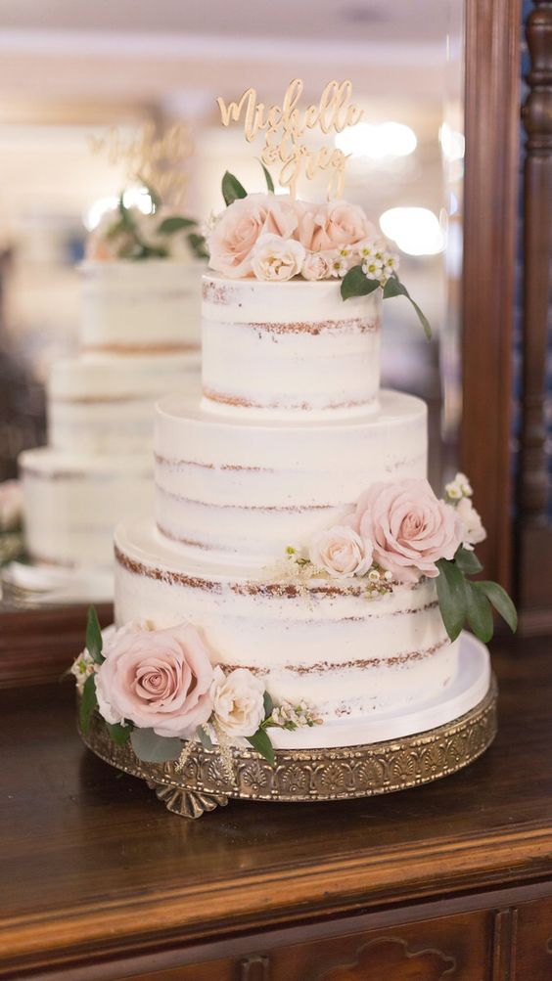
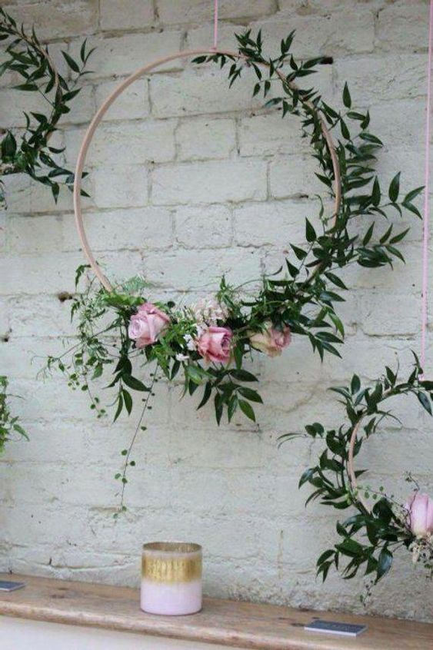
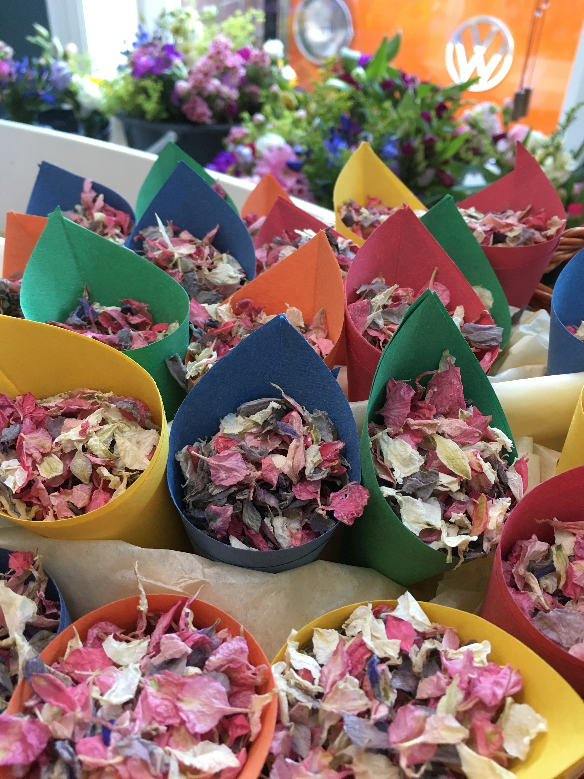
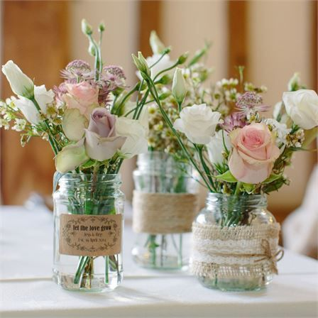
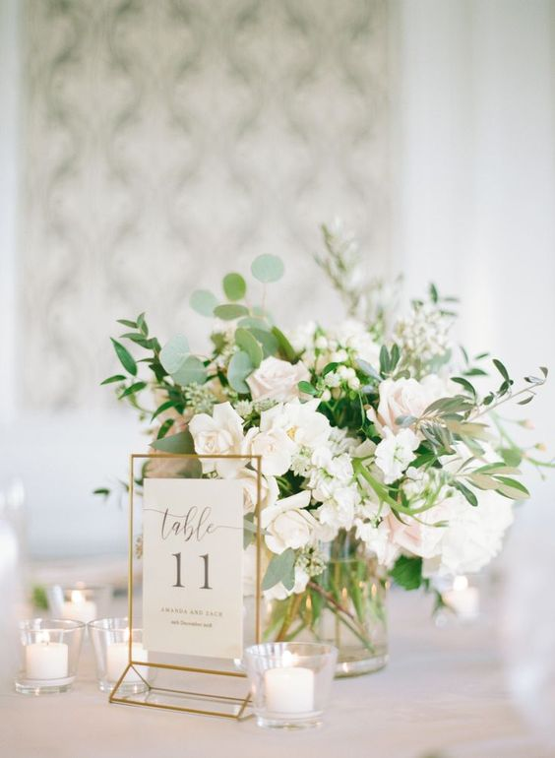
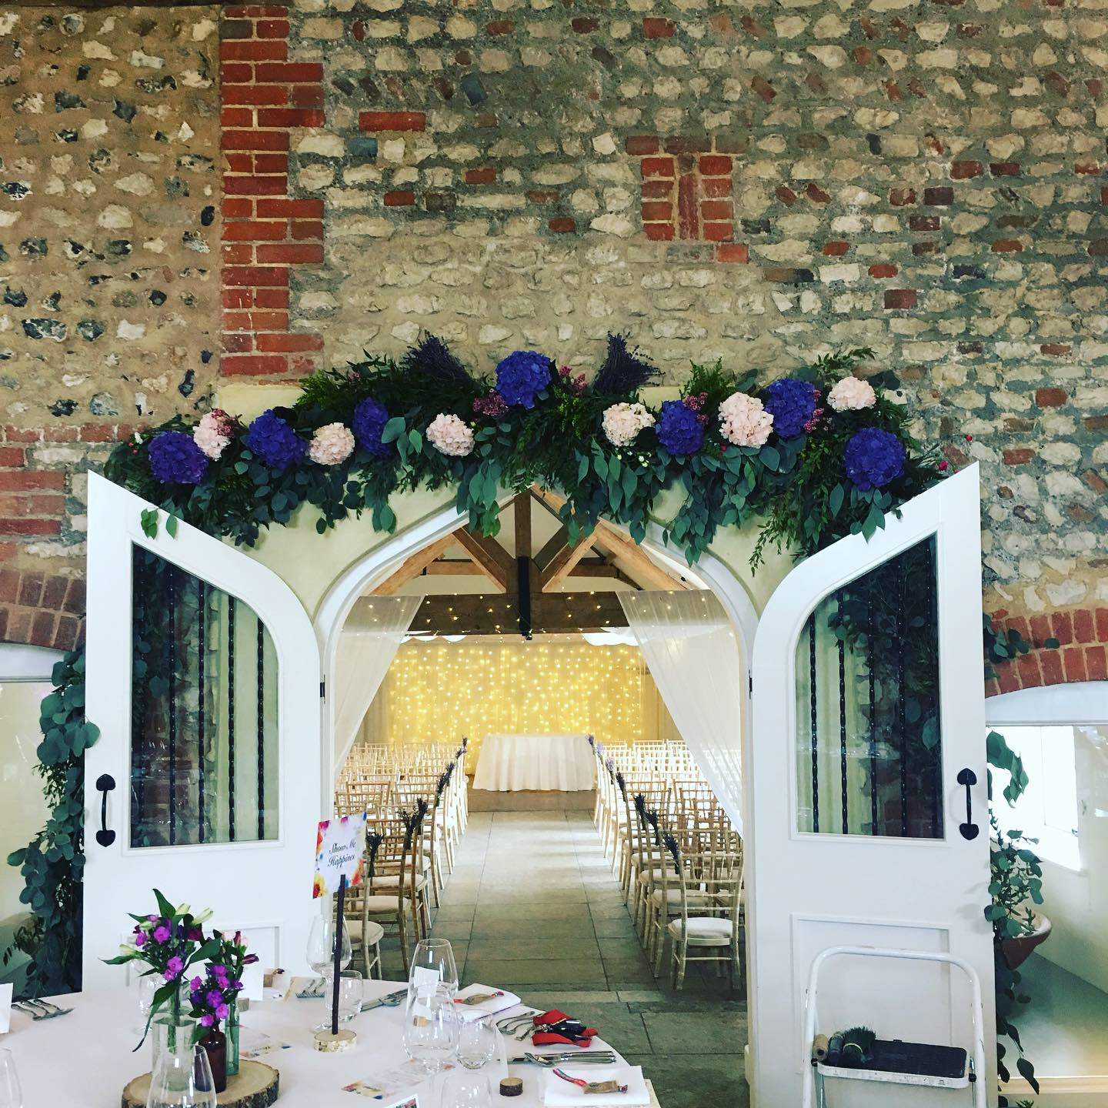
  - Wedding Flowers

Roots Creative Floristry

Where

Who

When

Here we can try out some colour palettes and explore the flowers available around your special date. This will help us to build the vision and concept for your wedding. Here is an example.
Wax flower
Astilbe
Delphinium
Astrantia
Ranunculus
Nigella
Gypsophila
Memory Lane Rose
Thistle
White
Vintage Pink
Dusty Blue

Colour Scheme and Style
Mums Lapel Corsage £12.50
Flower Girl Wand £25
An idea of prices for arrangements for the Bridal Party. These can vary as flower prices fluctuate throughout the year (and from flower to flower), but can give you a good idea of the price structure. We will find images to match your colour scheme and style to help you to visualize.
Altar/Registrar’s Table £55 per foot
Pew/Row End £20
Pedestal from £100
Planter from £95
Urn from £95
Ceremony and Reception Arrangements
Groom £14
Best Man £12
Ushers £10
Pageboy £9.50
Dads £10
Buttonholes
Flower Girl Heart £30
Flower Girl Basket £25
Mums Wrist Corsage £17.50
Flower Girls and Mums
Clip £25
Crown £50
Grips £2.00 per grip
Bridal Party Hair Options
Bride and Bridesmaids’ Bouquets
Cascading from £100
Large from £90
Small from £55
Medium from £75
Pomander from £85

The Bridal Party
The Delivery and Set-up
Delivery and set up of all arrangements, including up to three different locations (within a 10 mile radius)
£20+ dependent upon location and the nature of your order

The Deposit
Upon acceptance of your quote, a £150 refundable deposit is requested, in order to secure your date.

On-going support
Initial consultation and draft quote is free and no obligation. An hour’s work on your quote amendments and discussion regarding it are also free of charge. Thereafter I charge £15 per hour for time spent on your quote. Arrangement creation time is included in above prices.

The Admin
Mini Plant Favours £8.50 each
Thank You Bouquet £35
Flower wall £55 per 60cmx60cm section
Cake Tiers £15 per tier
Confetti cone £3
Ceremony and Reception Arrangements
Table Centre-piece from £35 (many options)
Archway Garland £55 per foot
Jam Jar £20
Hanging hoop from £45
Ceremony and Reception Arrangements

